**Dr. Rafiq Zakaria College for Women**

**Department of Computer Science**

**Departmental activities**

**2018 – 2019**

1. **Guest lecture on Advances in DBMS** was conducted on 15th Sep – 2018, the guest of honor was Dr. Mukta Dhopeshwarkar Asst. Prof. at Dr. BAMU, A’bad.

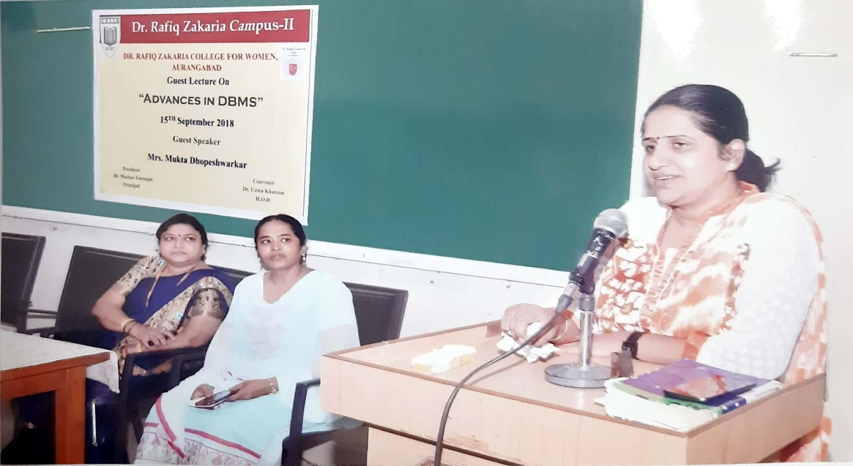

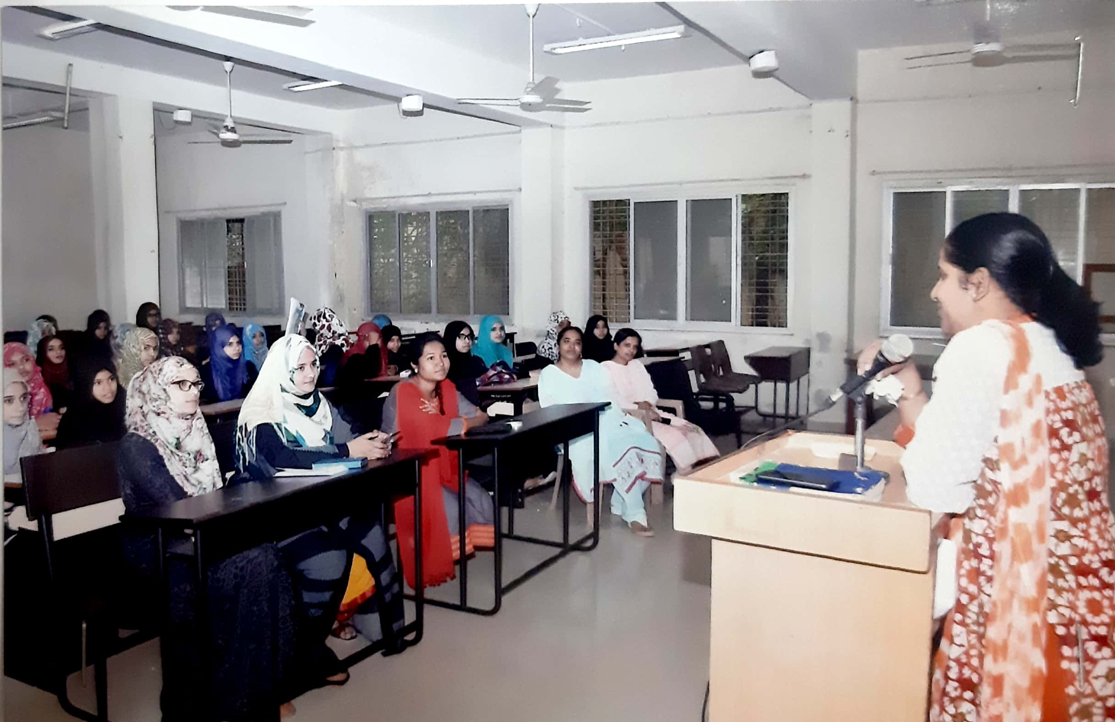

1. Students of BCS have **participated** in Aurangabad district **AVISHKAR 2018** organized by Dr. BAMU and M.S.P MandalsDeogri college, Aurangabad on 11th December.

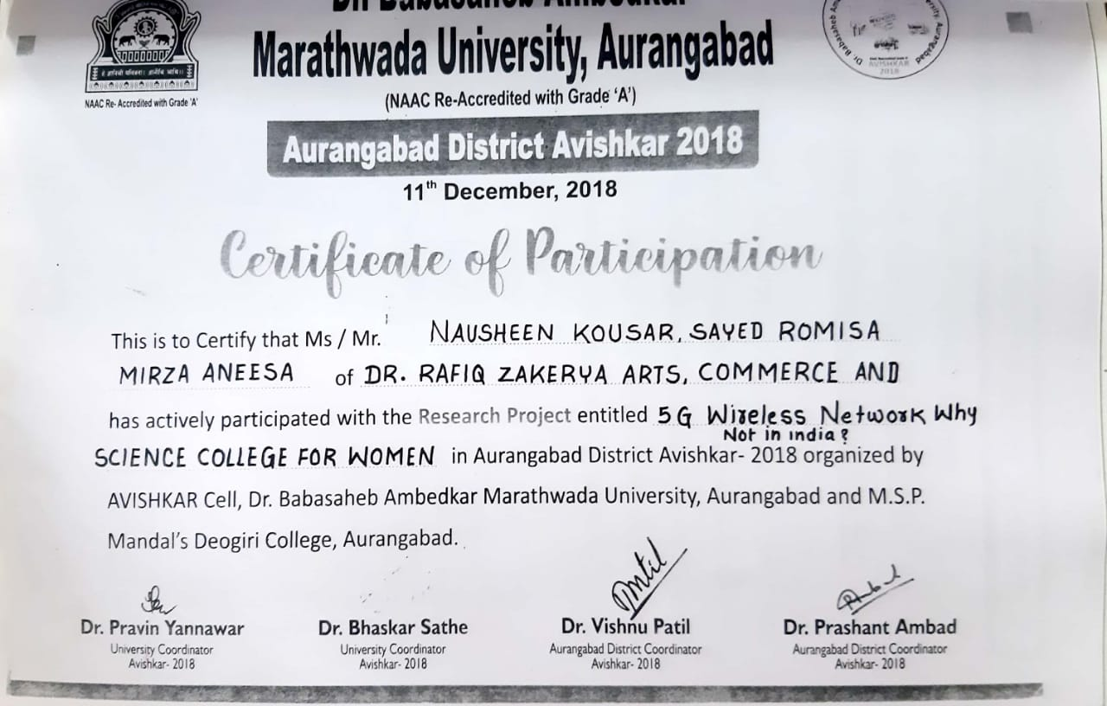

1. Guest lecture on **Internet of things (IOT)** was conducted on **12th Feb 2019,** the guest of honor was Dr. Bin- Naser Aziz Abdullah Asst. Prof. Sir Sayyed College, Aurangabad.

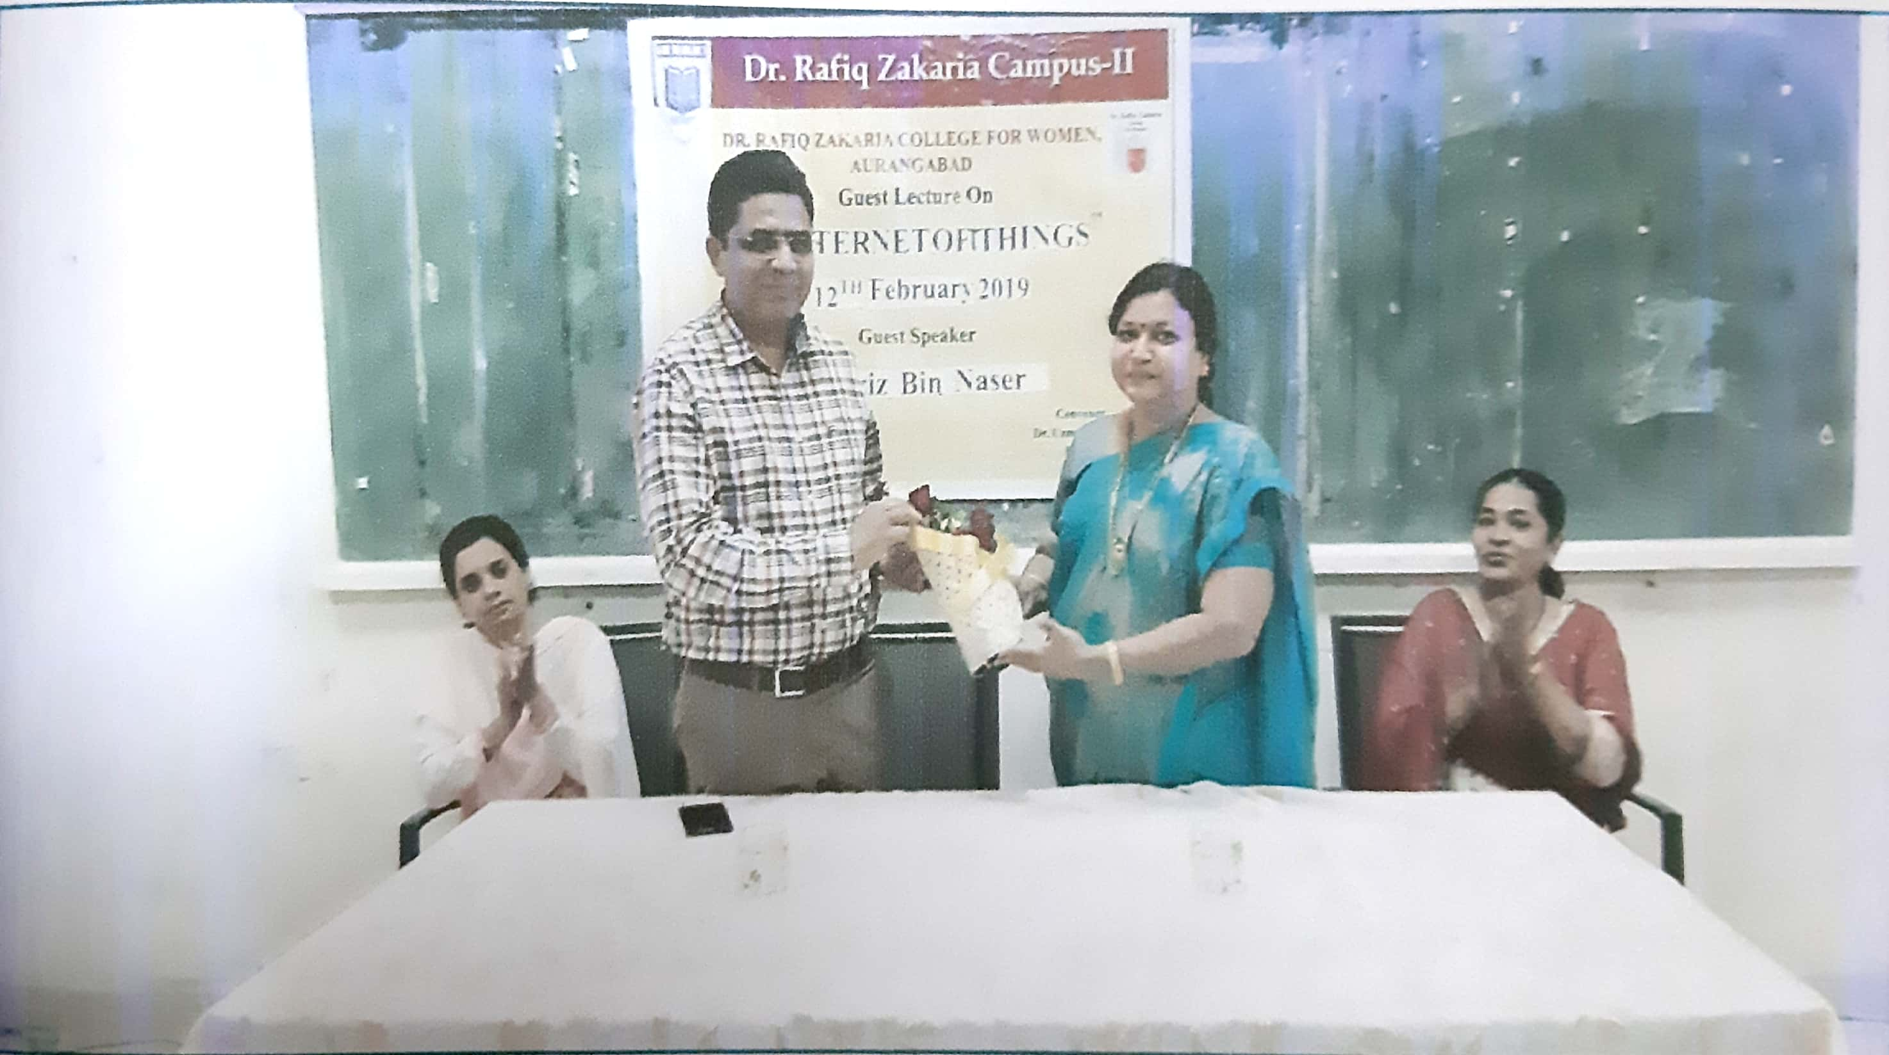

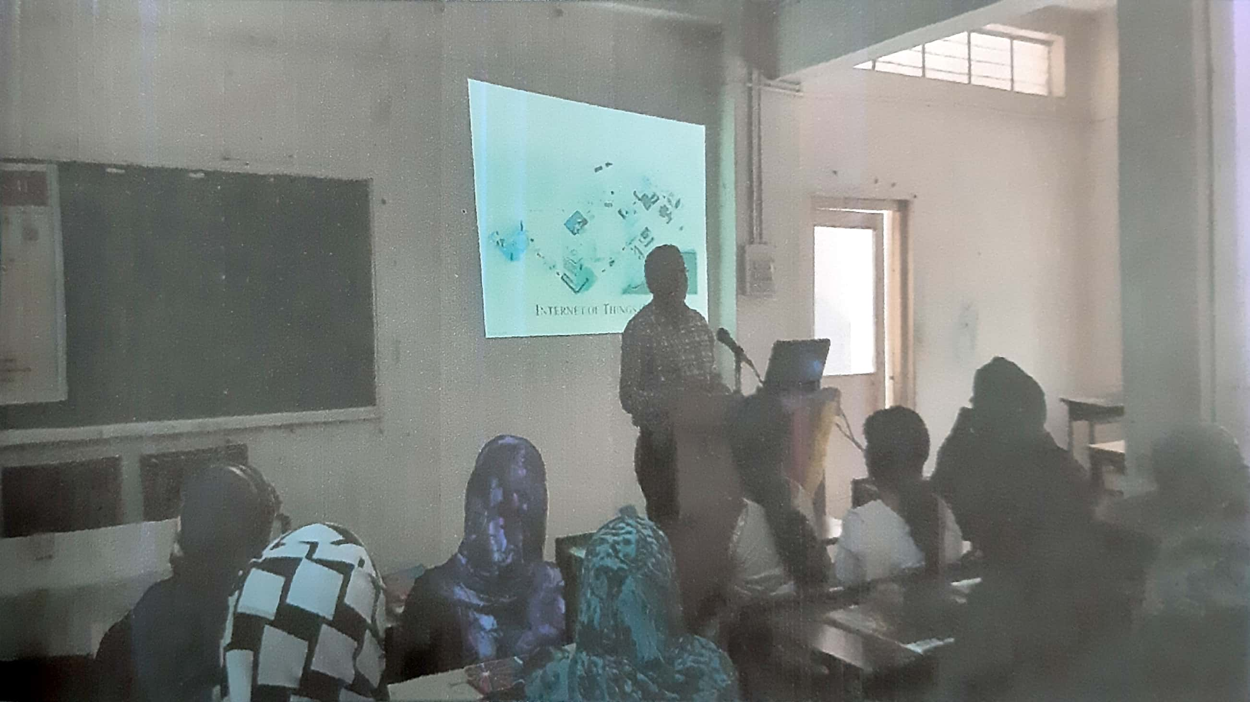

**Dr. Khan UzmaKhatoon**

**H.O.D**

Dr. Rafiq Zakaria Campus-II

**Dr. Rafiq Zakaria College for Women**

Navkhanda Jublee Park, Aurangabad

**Computer Science Department**

Departmental Activity Detail 2019-20

1. Departmental Study Tour to Pulsi: To study Land Degradation and Soil Detection on 3-8-2019.

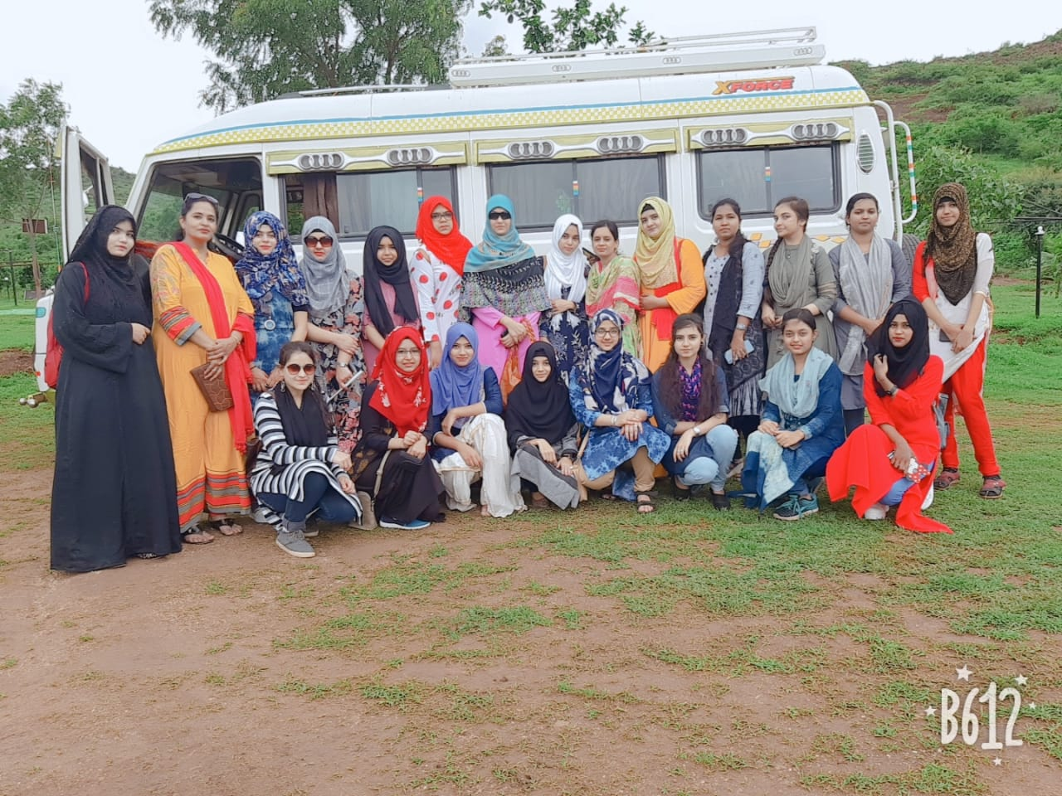

1. Guest Lecture on “Operating System & Scheduling Algorithms by Dr. Mukti Eknathrao Jhadav Principal MIT College Aurangabad on 4-9-2019.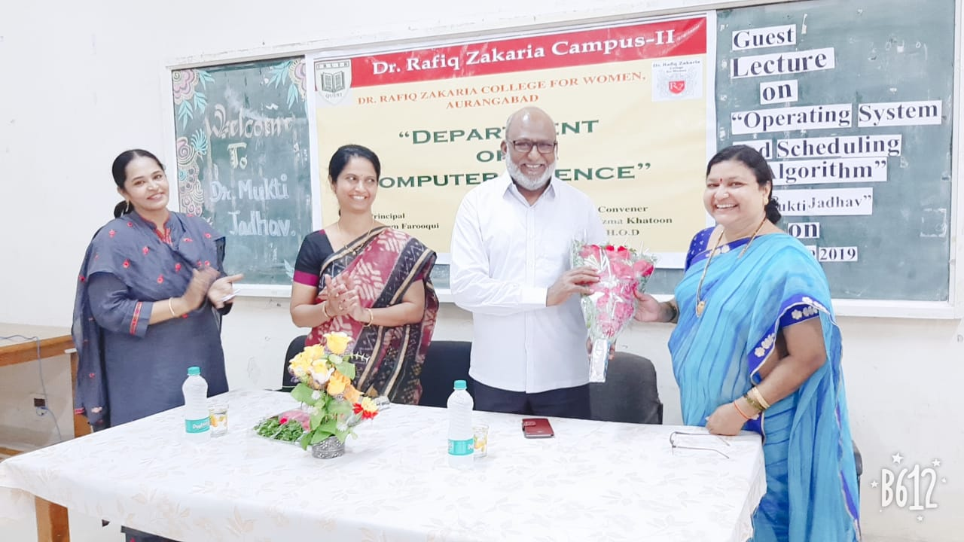

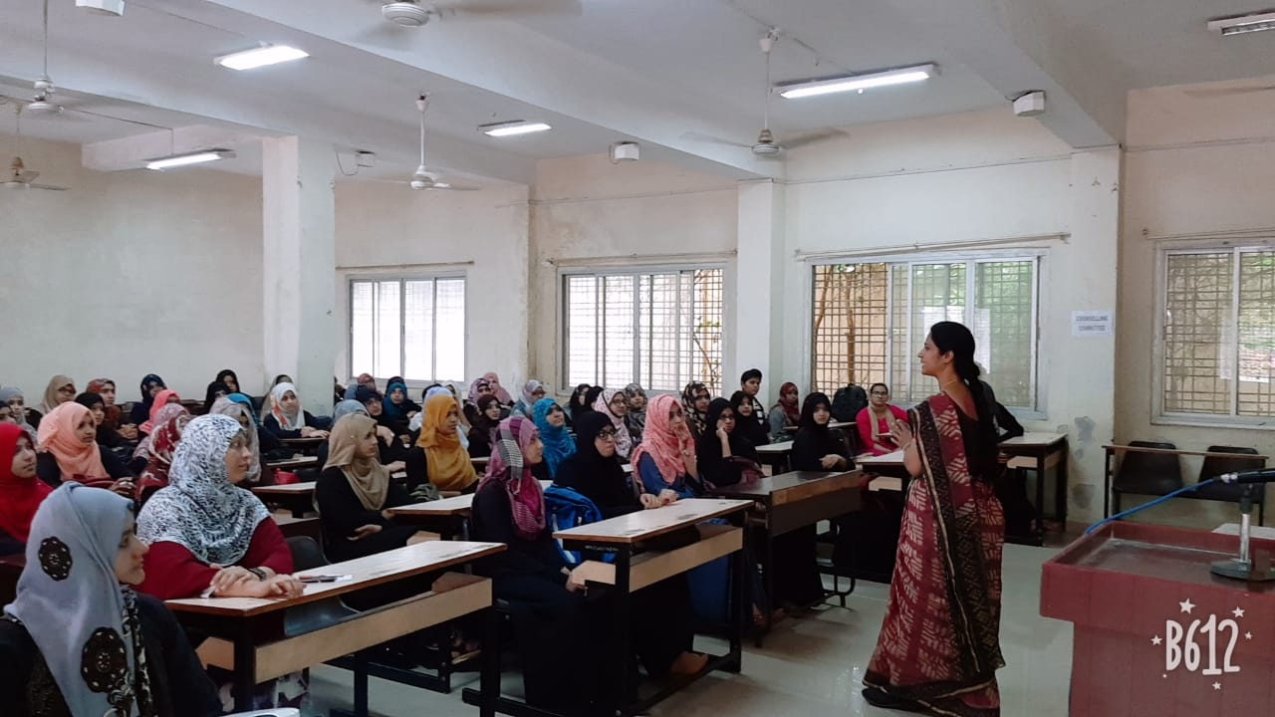

1. Inter-College University level Poster Competition held on 14/9/2019. The Judges were Dr. Shobha K. Bawiskar Asst.Prof. Dept. of Digital and Cyber Forensics.Govt. Institute of Forensic Science Aurangabad and Mr. G. K. N. Awasthi Asst. Prof. Vivekanand College.

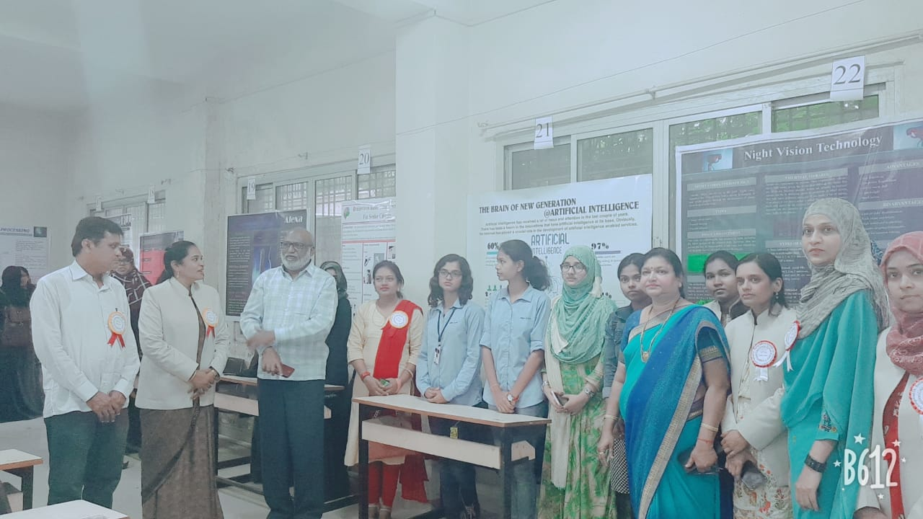

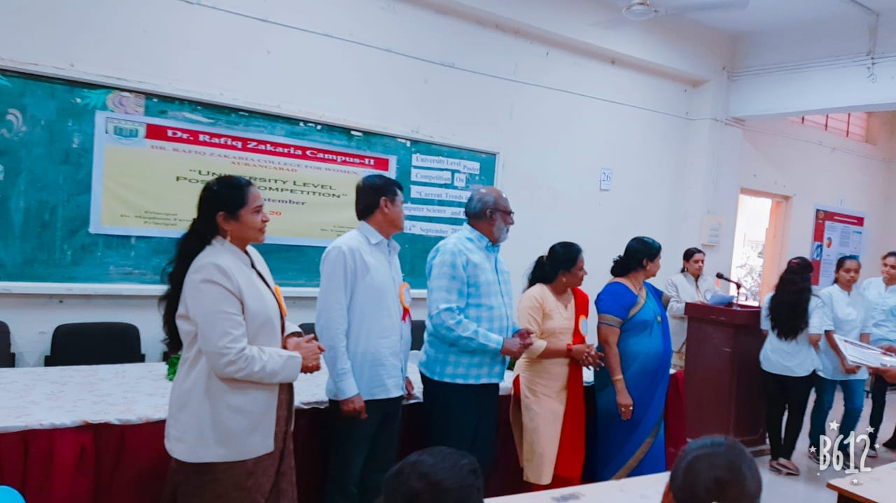

1. Guest Lecture on “Statistical Methods & Software used to Analyze Data” by Dr. Mansi Baheti Asst. Prof. Computer Science & IT Dr. BAMU on 19-12-2019.

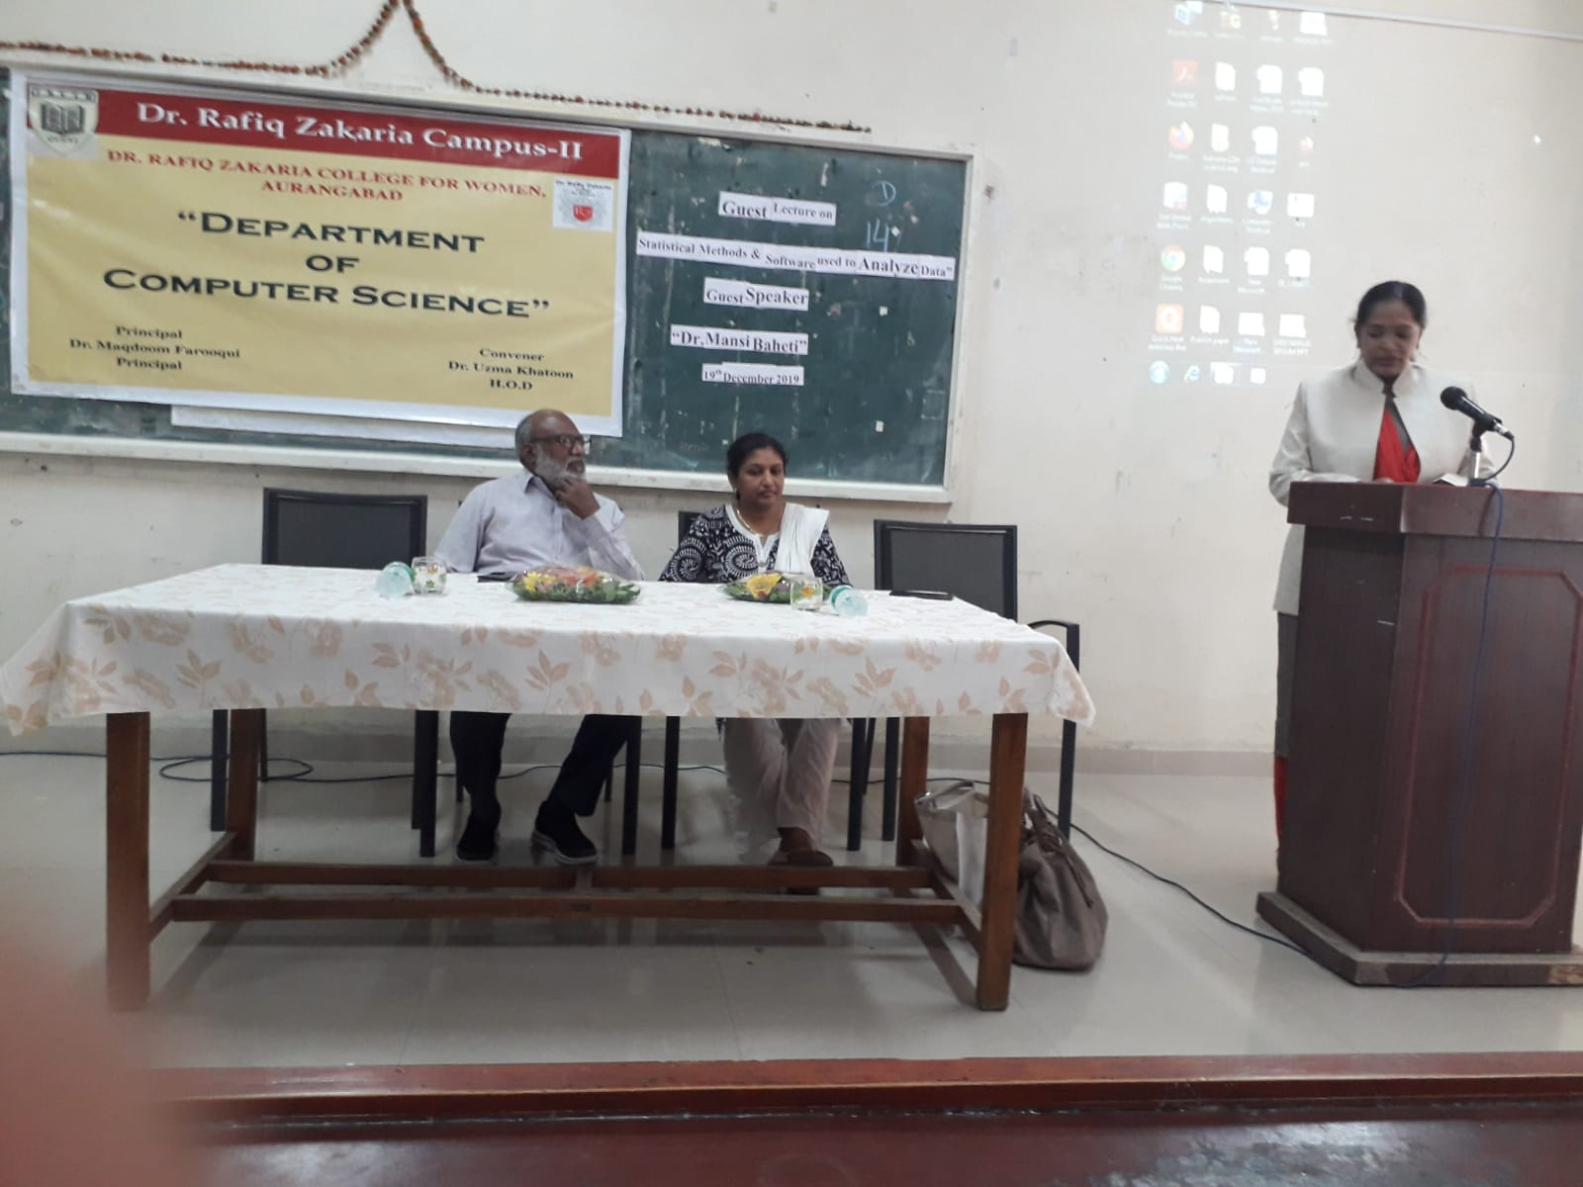

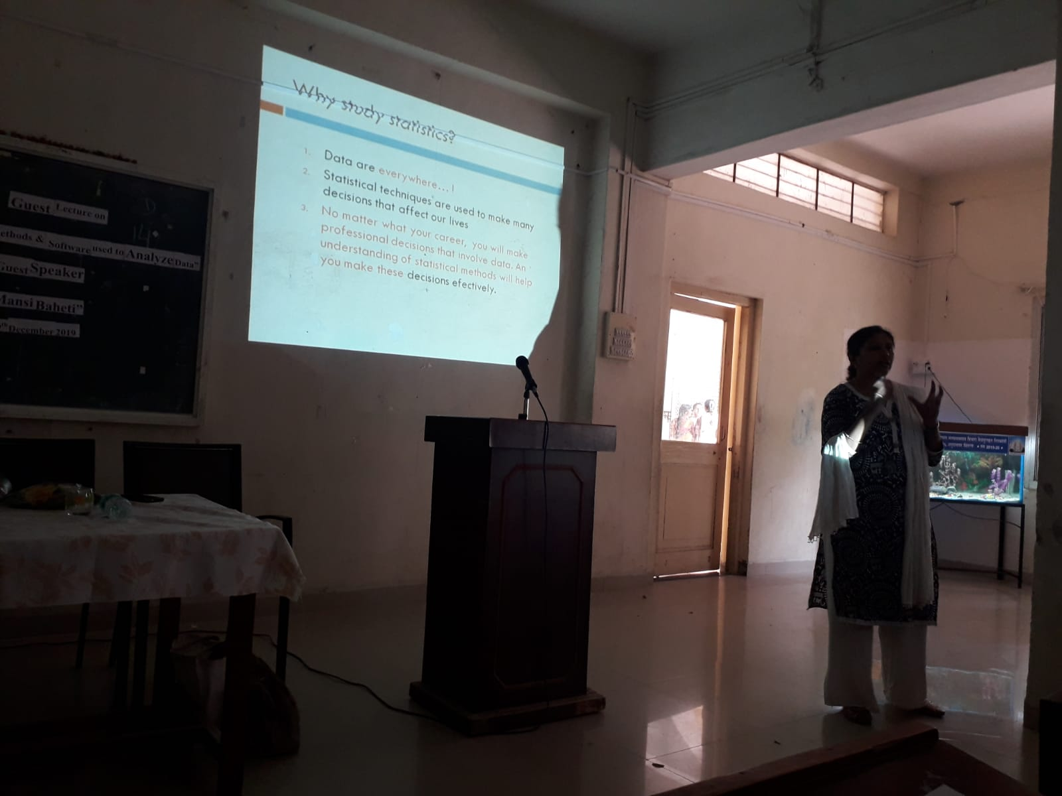

**Dr. Khan UzmaKhatoon**

**H.O.D**

**Dr. Rafiq Zakaria College for Women**

**Department of Computer Science**

**Departmental activities**

**2020 – 2021**

1. Workshop on **“Crimping and Fixing own Ethernet cable”** by Shaikh Usama Hardware Engineer Maulana Azad college Aurangabad on 18th Oct 2020.

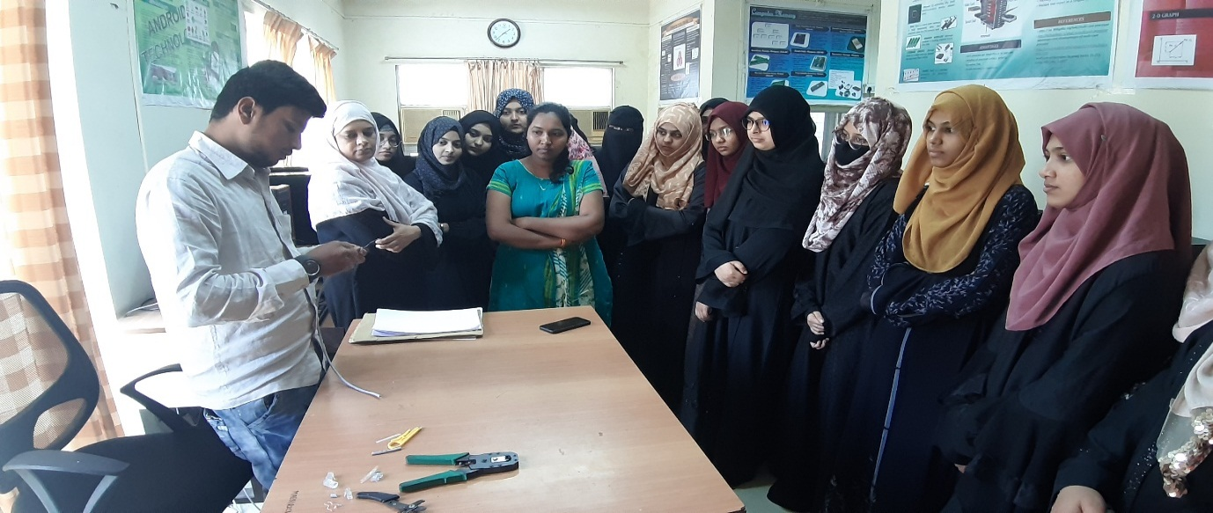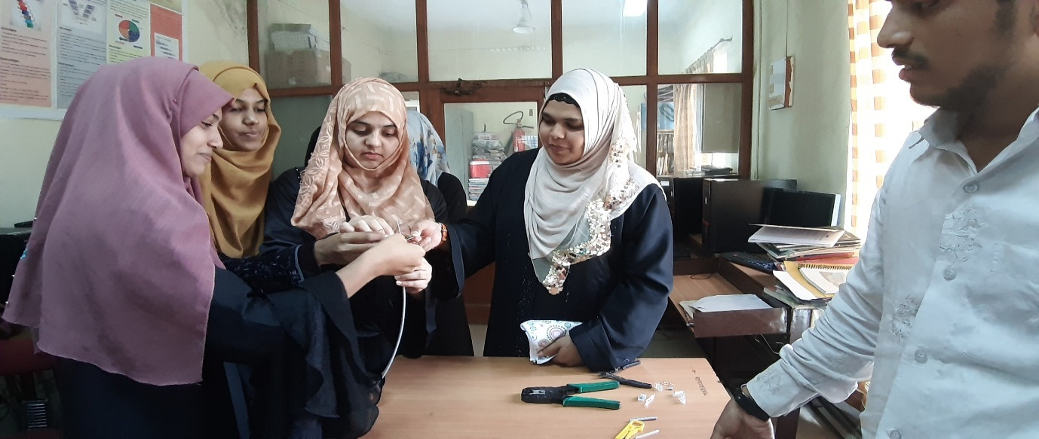

1. Workshop on **“Formatting and Installation of Windows 7 and 10”** by Shaikh Usama Hardware Engineer Maulana Azad college Aurangabad on 29th Nov 2021.

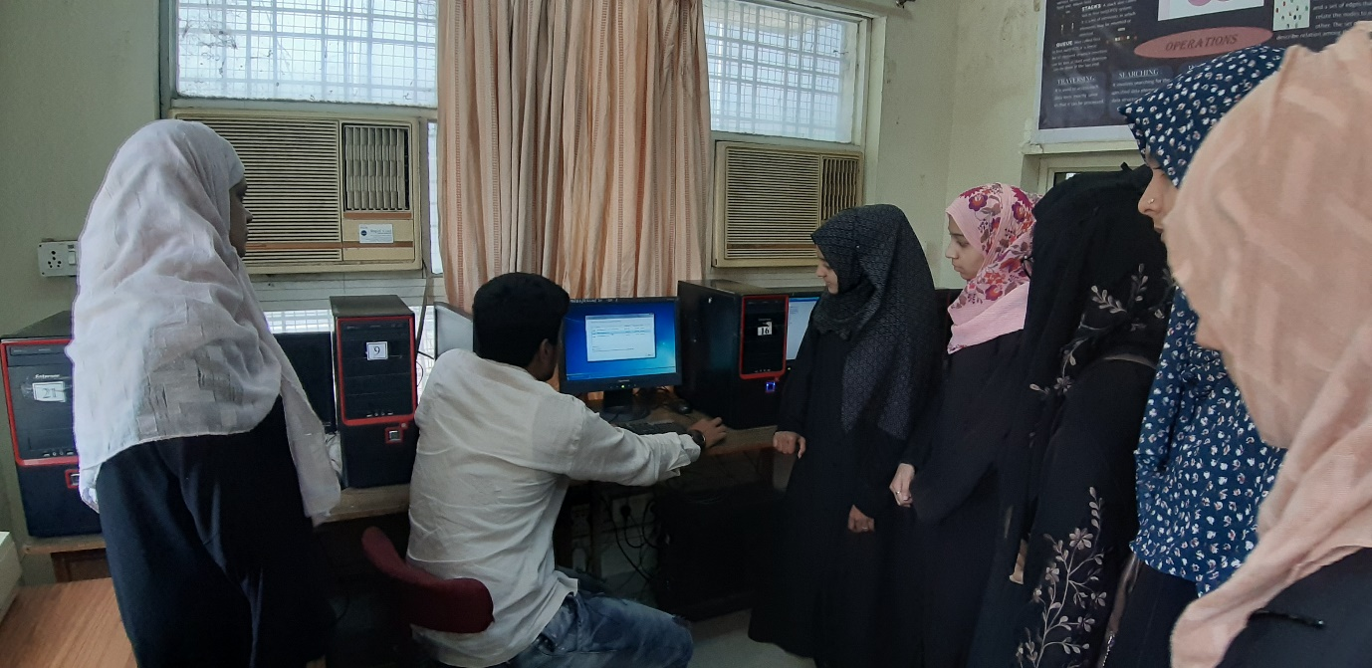

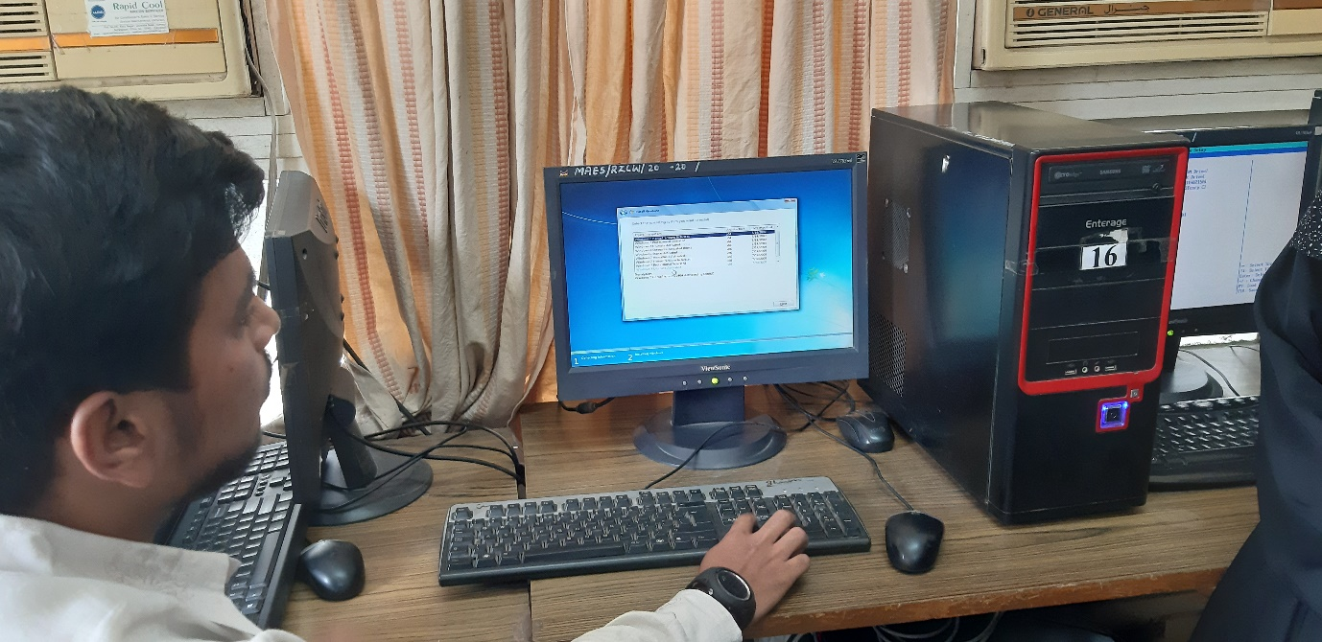

**Dr. Siddiqui Bushra Zareen**

**H.O.D**