**Dr. RAFIQ ZAKARIA COLLEGE FOR WOMEN, DR. RAFIQ ZAKARIA CAMPUS-ll NAVKHAND PALACE, JUBILEEAURANGABADM.S.**

**PART A: GENERAL INFORMATION AND ACADEMIC BACKGROUND** 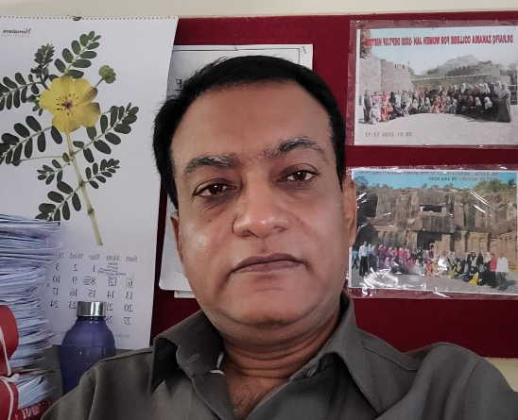

**1. Name (in Block Letters): Dr. ABDULLAH BASIT CHAOUSH**

**2. Department : HISTORY**

**3. Current Designation & Academic Level : ASST. PROFESSOR**

**4. Address (With Pin code: Department of History, Dr. Rafiq Zakaria College for women, Navkhanda, Jubilee Park, Aurangabad Pin. 431001 M.S. India. Mobile No. : 9028212147**

**5. E-mail : abdullahchaoush@gmail.com**

**6. Academic Qualifications (UG & PG) : Examinations Name of the Board / University / Year of Passing Percentage of Marks Obtained /Division / Class / Grade Subject:**

**1. U.G. Dr. B.A.M.U. Aurangabad Mar/Apr 1988 55.20%II History, Sociology & Urdu**

**2. P.G. MANUU, Hyderabad 2008 69.50% I History.**

**3. P. G. Dr. B.A.M.U. Aurangabad 1993 50.50% II History**

**4. Research Degree(s):**

**Degrees---- Title------ Date of Award------ Name of University---- Ph.D. / D.Phil.:**

**“BHARTIYA SWATANTRA CHDWADIT MAULANA MAHEMUDUL HASAN YANCHE YOGDAN”**

**5 Th October2007 - Dr. Babasaheb Marathwada University, Aurangabad. M.S.**

**5. Posts held after appointment at this institution:**

**Assistant Professor in History Department: 21-10-2016**

**6. Period of teaching experience: 6 YEARS**

**7. Fields of Specialization under the Subject / Discipline: Modern Indian History: Medieval Indian History**

**8. Human Resource Development Center Orientation / Refresher Course / FDP/ MOOC / One-Two week courses attended so far:**

**Name of the Course--- Place------ Duration---- Date--- Name of Organizer---**

**9. 121st Orientation Course programme Successfully Completed Grade-A UGC_ASC, Dr. Babasaheb Ambedkar Marathwada University, Aurangabad.**

**(Four Weeks) 01-10-2012 to 31-10-2012, UGC New Delhi & ASC Dr. BAMUA.**

**10. Refresher course in “Managing Online Classes and Co-creating Moocs: 2.0” Teaching Learning Ramanujan College University of Delhi (Online) 14 days 18.05.2020 to 03.06.2020 Govt. of India M.H.R.D. & Ramanujan College University of Delhi**

**11. Refresher course in “Managing Online Classes and Co-creating Moocs.0” Teaching Learning Ramanujan College University of Delhi (Online) 14 days 25.07.2020 to 10.08.2020 , Govt. of India M.H.R.D. & Ramanujan College, University of Delhi**

**12. One Week FDP Programme on “Open Sources Tools for Research” Teaching Learning Ramanujan College University of Delhi (Online) & MHRD Pandit Madan Mohan Malaviya NMTT 7 Days , 08.06.2020 to 14.06.2020 Govt. Of India M.H.R.D. & Ramanujan College, University of Delhi, & Madan Mohan Malaviya NMTT**

**13. One Week FDP Programme on Teaching Learning Ramanujan College University of Delhi (Online) & MHRD Pandit Madan Mohan Malaviya NMTT 7 Days , 23.06.2020 to 29.06.2020 ,Govt. of India, M.H.R.D. & Ramanujan College, University of Delhi, & Madan Mohan Malaviya NMTT**

**Department of History Learning Goals and Objectives**

* **Learning Goal: Students will analyze and demonstrate knowledge of the history, or change over time, of different regions of the world.**

**Objectives:**

**1. Examine the history of the India and the new nation.**

**2. Critique the domestic and foreign policy of the India.**

**3. Evaluate the historical importance of the all phases of Indian History.**

**4. Appraise the historical significance of modern India in the global arena.**

**5 Examine the historical significance of different cultures of the world.**

**6 Assess the historical importance of modern cultures.**

* **Learning Goal: Students will acquire and demonstrate skills in critical analysis of primary and secondary historical sources.**

**Objectives:**

1. **Interpret documents, and other forms of evidence, in their historical context.**
2. **Differentiate between historiographical theories and debates in the field.**

* **Learning Goal: Students will be able to develop in written papers well-reasoned historical arguments, supported by judicious use of sources.**

**Objectives:**

1. **Formulate important historical questions.**
2. **Articulate a persuasive and well-structured historical argument.**
3. **Employ multiple forms of evidence in this historical argument.**

* **Learning Goal: Students will be able to articulate historical arguments orally.**

**Objectives:**

**1. Participate in debates and other forms of verbal historical discussion.**

**2. Deliver a historical presentation orally.**

* **Learning Goal: Students will be able to conduct intensive research in primary and secondary sources, and to complete a major research paper on an original topic.**

**Objectives:**

1. **Conduct original research in published or unpublished primary sources**
2. **Develop, under supervision, a substantial research paper.**
3. **Engage in an ongoing process of writing and revision**

**4. Report orally on research and written work**

**Student Learning Outcomes**

* **The ability to demonstrate content knowledge of world cultures and their interconnection to global forces as they change over time.**
* **The ability to think historically: identifying the unique characteristics of past eras, articulating causality, and analyzing change over time.**
* **The ability to interpret in their historical contexts an array of primary sources, including manuscripts, artifacts, quantitative, oral or visual sources.**
* **The ability to engage critically with historical argument: identifying underlying theories, assumptions, and approaches.**
* **The ability to conduct original historical research using primary and secondary sources, and placing one’s own work within historical debates.**
* **The ability to communicate historical knowledge, interpretations, and arguments clearly in writing, oral presentations, or public history projects.**

**CHB TEACHER IN HISTORY DEPARTMENT**



**Position & Qualification:**

**H.O.D**

|  |  |  |
| --- | --- | --- |
| **Sr. No.** | **Name** | **Link** |
| **1** | Dr. Abdullah Basit Chaoush |  |

**CHB**

|  |  |  |
| --- | --- | --- |
| **Sr. No.** | **Name** | **Link** |
| **1** | Dr. Syeda Lubna Shireen |  |