**Curriculum Vitae.**

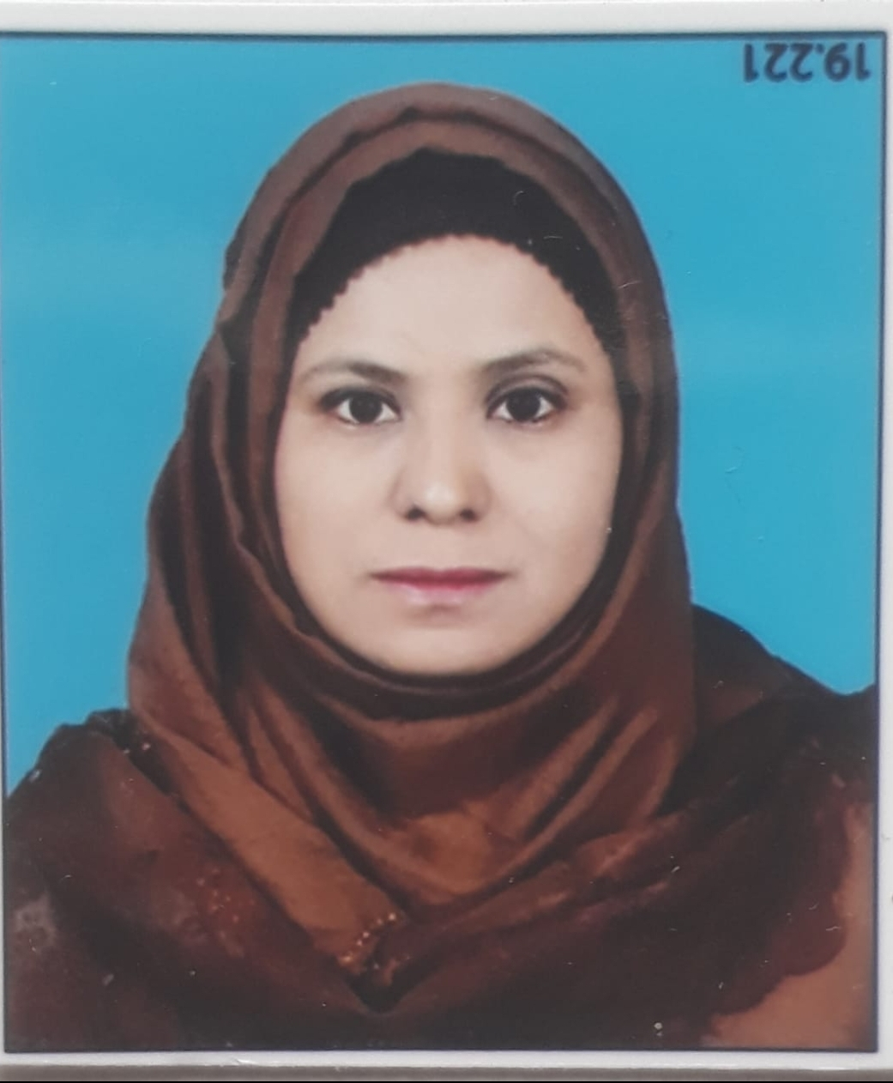

**Dr. Shaikh Kaneez Fatima**

**D/O Shaikh AbdulGaffar.**

**Address :- H. No. 5-1-50 mill Corner,**

**Barapulla Gate, Aurangabad.**

**Pin Code 431001.**

**Contact No :- 7769969646**

**Objective :-**  ( To accept challenges, dare to innovate and to utilise my skills to attain organization. Mission through sincerity, hard work, determination.)

**General information**

**Name :-Dr. Shaikh Kaneez Fatima D/O Shaikh AbdulGaffar.**

**Address** :-  **H. No. 5-1-50 mill Corner, Barapulla Gate, Aurangabad.**

**Pin Code** 431001.

**Contact No** :- **7769969646**

**Email id:-** **dr.kaneezfatima07@gmail.com**

**Gender :- Female.**

Nationality :**- indian.**

**Religion:- Islam.**

**Cast :- Open.**

**Academic Qualification**

**___Examination___**

**SSC**:-  **Borad/University:- MSBSHS**

**Subject:-Urdu.English,Marathi, Mathematics, History geography.**

**Year/Month:-**Mar-1999

**Division:-**1st

**Percentage:-**63.20%

**HSC:- Borad/University:- MSBSHSE**

**Subject :-Urdu , English, History, Political science.**

**Year/Month:**-  **Feb, 2001.**

**Division:-** 1st.

**Percentage:-**62.00%

**B. A. :- Borad/University:- Dr. B. A. M. U. Aurangabad.**

**Subject :**- Urdu, Political sciencee,Home Science**.**

**Year/Month :- Mar-2004**.

**Year/Month :- Mar-2004**.

**Year/Month :- Mar-2004**.

**Division:**-**2nd.**

**Percentage:-**56.88%.

**B, ed:-**

**Dr. B. A. M. U. Aurangabad.**

**Subject:- Urdu, Geography.**

**Year/Month:-** March 2011.

**Division:-**1st. .

**Percentage:-**62%

**M. A. :-**

**Dr. B. A. M. U. Aurangabad**.

**Subject:-**Urdu.

**Year/Month:- March 2006.**

**Division.**1st.

**Percentage:-** 73%

**Phd:-**

Dr. B. A. M. U. Aurangabad

**Subject:- Urdu.**

**. Topic :- "Urdu Prose in Marathwada After Independence "**

**List Of Publications :-**

**(A)**

**1:-Kitabi Silsila No3, AalamgeerAalamgeer urdu AdabAdab.**

**"Chubti Hui Apnayat khaka Nigaar"**

**Page No 89.**

**2:-:- Kitabi Silsila No3, AalamgeerAalamgeer urdu AdabAdab.**

**"Sachaiyun ka Imandaar fankaar"**

**2015 Page No 112.**

**3:- Kitabi Silsila No 7,Noor ull Husnain: Shaksiyat Aur Adabi Jihaat.**

**"Noor Ull Hasnain Bhasiyat Afsana Nigaar " 2018. Page No 89.**

**One of my Article Published in daily newspaper Dated 30.04.2022.**

**Topic :- Akhbaaraat ki Taeekh, Ahmiyat, Manviyat O Ifadiyat.**

**(B)**

**List of Books /Reviews/Written :-**

**"Naya Afsana Naye Naam" By Noor ull Husnain.**

**ISSN-NO:- 978-93-8109-29-9**

**Year :-2012.**

**Page No 323**

**\* Two Books are under publish.**

**Awards And Honours Received :-**

**1. International:-**

**2:- National :- 1**

**Padmshri Sikander Ali Wajd Urdu Paritoshik For Having Secured Highest Number of Marks in M. A Urdu Examination Held in March 2006.**

**Job Experience.**

**1:- I Have Working as an Assistant Professor (CHB) In Dr. Rafiq Zakariya College For Women Since 2012 to date.**

**2:- I Have been Working as a Compere Of Urdu Program SABRANG. in All India Radio Aurangabad Since 2006 to date.**

**Other Diplomas & Certificate Course :-**

**1:-**

**Diploma in Computer Software.**

**2:-N. S. S. Certificate :- completed Two years in NSS as a volunteer 2002/2004.**

**3:- Class 5th"Idaara e Imtehaan Deeniyaat" SIO Examination. jan1995. 2nd.**

**4:- Class 6th, Bombai Hindi University, Hindi pravash Pariksha 26.jan 1996.2nd.**

**5:-Class 7th Idaraa-Imtehaan**

**Mutallim Deeniyaat Awwal. 1st rank Nov 1997.**

**6:-Class 8th**

**"Majlees e Ishaat e islam Aurangabad". Deeniyaat Aug 1998.**

**7:- Class 11th**

**Mutala e Deeniyaat 1st.**

**Awards & Prizes.**

**1:- When I was a Second year BA student at Aurangabad College for Women, I won second prize in essay writing competition in 2002.**

**2:- When I was a third year BA student at Aurangabad College for Women, I won first prize in a debate competition. in 2004.**

**3:- When I was a third year BA student at Aurangabad College for Women, I won the first prize in baitbazi competition. In 2004.**

**4:-I have been working in Akashwani Aurangabad for the last 16 years.**

**\* Many of my articles were broadcast on All India Radio.**

**\* During this time I did many programs, including literary and social topics.**

**\* I have Conducted many times the literary program "Bemisal adabi shaksiyat " and I have also participated in this program**

**Such as**

**1:-Quli Qutb Shah.**

**Date of Broadcast ......**

**2:-Bahadur Shah Zafar**

**Date of Broadcast .....**

**3:-Nazeer Akbar Abadi**

**Date of Broadcast .....**

**4:-Khwaja Mir Dard Date of Broadcast .....**

**5:-Maulana Abul Kalam Azad**

**Date of Broadcast ....**

**6:- Qurrat-ul-Ain Haider**

**Date of Broadcast ....**

**Etc.**

**\*I have interviewed many writers and poets under the program name**

**"Main Aur Meri Qalamkari"**

**Such as, The poet,**

**\* Shah Hussain Nahri,**

**Date of Broadcast....**

**Poet,**

**\*Athar Aurangabadi,**

**Date of Broadcast....**

**\* Poet, Rana Haideri,**

**Date of Broadcast....**

**Short story writer,**

**\* Dr. Azeem Rahi.**

**Date of Broadcast....**

**Critic,**

**\* Dr. Siddique Mohiyyudin.**

**Date of Broadcast....**

**Critic and commentator**

**\* Dr. Irtekaz Afzal Khan.**

**Date of Broadcast...**

**Etc.**

**\* I have interviewed the specialist doctors several times about various diseases under the program Jan Hai To Jahan Hai.**

**\* I have presented programs many times for youth under the youth programme Karavan E Nawjawan program.**

**\* I did and presented programs like Shagufta Bayani Meri, Science Nama, Bazm-e-Sukhan, Khilti Kaliyan etc.**

**\* Many times I have written programs on Mujahideen Independence in view of 75 years of Independence Day celebrations like Shaheed Ashfaqullah Khan, Maulana Muhammad Ali Johar, Bhagat Singh, Maulana Abul Kalam Azad etc.**

**\* I have directed the Women's Program. several times.**

**\* Many times I have presented programs on famous women under the program of women historians such as Razia Sultana, Azizan Fatima Sheikh, Savtri Bai Phule, Amina Tayyab G, B Amman etc.**

**\* I have done many programs on All India Radio under Baatein Filmon ki , such as "Hindustani Filmon mein ghazal"**

**\* The role of Urdu writers and poets in Indian films,**

**Hubbul watni se sharsaar filmein. Hindustani Filmon mein Hasrat Jay Puri ki Naghma nigaari, Hindustani Filmon mein Majrooh Sultanpuri ka Kirdaar etc.**

**\* I have directed the literary program Aina many times.**

**\* This is certifieisd that that I have attended VANI Certificate Course at All India Radio Aurangabad From 16th June 2014 to 20th June 2014.**

**\* I have Presented & Conducted The Special Programe on Padmshri Fatima Zakariya.**

**"Padmshiri Fatema Zakariya Ek Mayanaaz Shaksiyat "**

**Date of Broadcast . 08.04.04.2021.**