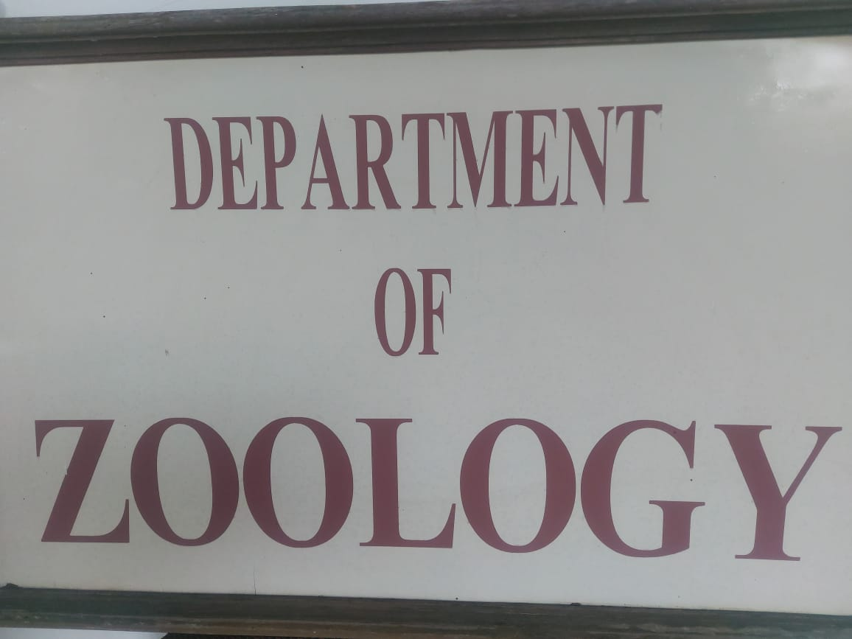

ZOOLOGY DEPARTMENT

2020-21

|  |  |
| --- | --- |
| Sericulture lecture | Silk worm Rearing 29 Nov 2020 |
| Dr. Salim Ali Lecture Series (Inauguration) | 12 Nov 2020 |
| Bird watching (Jayakvedi Bird Scantuary) | 20 Feb 2021 |
| Celebration of wild Life Week | 6 Oct 2020 |
| AID’S Day (Poster Exhibition) | 3 Dec 2020 |
| Visit to Aquarium | 18 Nov 2020 |
| Study Tour to Siddharth Garden | 18 Nov 2020 |
| Sericulture Visit to KiKat Jalgaon (small scale Farmers) | 19 Nov 2020 |
| Blood Group Testing | 1 Dec 2020 |
| Anti-Dengue Poster Exhibition | 15 Feb 2021 |
| Vermi Composite (Farmers) | 21 Nov 2020 |
| Bee-Keeping (Importance for Healthy Fruit Growing for Farmers) | 29 Jan 2021 |
| Group Discussion | 7 Jan 2021 |
| Seminar on Time Management | 17 Nov 2020 |
| Applied for Certificate Course in Beekeeping (YCMU) Nasik | 27 Nov 2020 |
| National Seminar on  “ Multi-Disciplinary Approach in Research” March 2020 in Collaboration with analytical chemistry Teacher’s & Research’s Association | (9 Feb 2020) |
| National Conference on “Recent Developments in Life Science” | 23 Feb 2020 |

**Best Practice**

* Fund For AID’S Effected Children.
* Aware Various Diseases & Environment Consecration.
* Various Composite.

NSS Activities

2020-21

|  |  |
| --- | --- |
| Eye Checkup Camp | 6 Jan 2021 |
| Blood Group Testing | 2 Dec 2020 |
| Gandhi Jayanti Celebration | 2 Oct 2020 |
| Constitution Day Celebration | 2 Oct 2020 |
| Nam Vistar Diwas Celebration | 14 Jan 2021 |
| Blood Bank Visit |  |
| Dental Check of   1. Nutan Madhanj School 2. Hebibs School (120 Student Participate) |  |

“COVID-19”

Prof. Arun Sankrit Farmer V.C University of Reyashthan700 Registration

Phenyl Preparation by NSS Volunteers Distributed.

Women Cell 2020-21

* Visit To Begumpura Police Station - 24 Oct 2020
* Nutritional Balanced Diet Reciepe - 10 Nov 2020
* Exhibition on “Preparation of Home Decoration - 19 Oct 2020

(Interior Design)

* Women Empowerment Lecture Dr. Mubeen Zehera - 20 Jan 2021

(Dept of History) Delhi University.

* Visit of Dattaji Bhale Blood Bank- 12 Dec 2020
* Rangoli AID’S Awareness- 4 Dec 2020